**PUNE INSTITUTE OF COMPUTER**

**TECHNOLOGY**



**Department of Computer Engineering**

**LP-4**

**BATCH – P1**

**OOMD MINI PROJECT**

**UML COMPONENT DIAGRAMS REATED TO PROJECT WORK**

NAME – RITU CHUDIWAL

ROLL NO – 41117

GUIDED BY – PROF . D.D.BHAIYYA

**AIM –** To draw all UML Diagrams related to project work.

**PROBLEM STATEMENT** –

Draw all UML Diagrams related to your project work.

**THEORY –**

(1)What are UML Diagrams?

UML diagram is a diagram based on the UML (Unified Modeling Language) that is used to visually describe a system, including its major actors, roles, actions, artifacts, or classes, in order to better understand, edit, maintain, or document system information. Software engineers use the UML modeling language to create diagrams and provide ready-to-use, expressive modeling examples to users (programmers). Some UML tools create code in a programming language. The UML Diagrams are categorized into two types: the structural diagrams and the behavioral diagrams.

UML diagrams are the visual designs or the blueprint of the system structure and behavior. Structural diagrams helps in building the structure of Bank Management System while the behavioral diagrams in UML helps in determining its behavior towards the user, data inputs and producing an output. All of the UML diagrams works in sync and relatively to achieve a wellengineered project.

CLASS DIAGRAM :

The Class diagram for Bank Management System shows the structures of information or data that will be handled in the system. These data or information will be represented by classes. Each of the classes will have their attributes in accord to the methods they will use. So the UML Class diagram was illustrated by a box with 3 partitions and the upper part was the name of the class, the middles are the attributes and the bottom is for the methods. The arrows on them represents their relationships in each other.

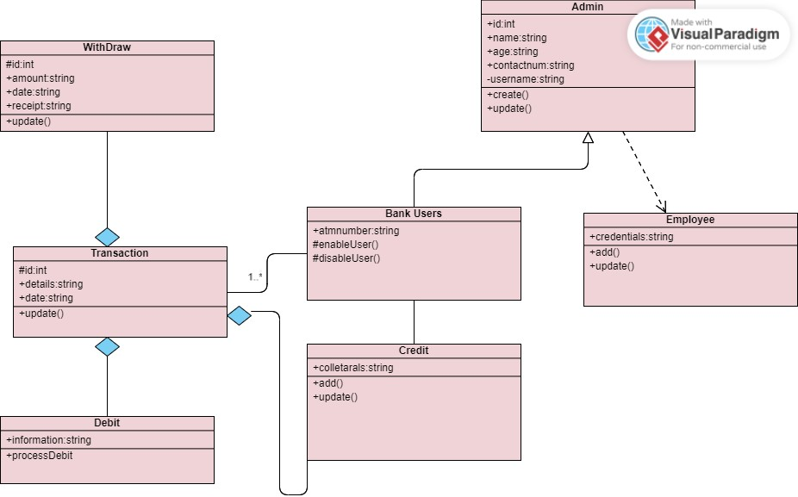

**USE CASE DIAGRAM**

The use cases in the diagram represents the main processes in Bank Management System. Then they will be broken down into more specific use cases depending on the included processes of the main use case. Each of these use cases explains how the system handles the actions or scenarios requested by the user.

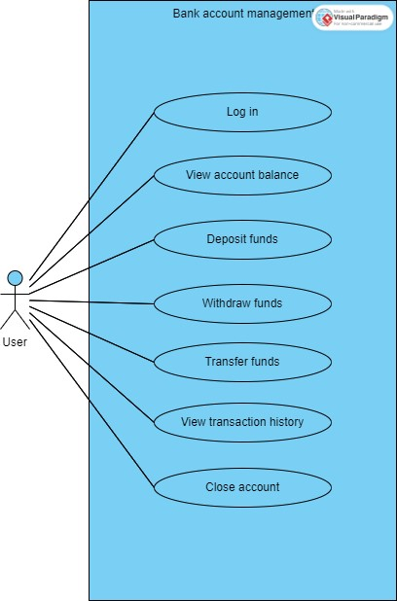

**SEQUENCE DIAGRAM :**

The designed sequence diagram illustrates the series of events that occurs in Bank Management System. In this illustration, the actors are represented by a stick man and the transactions or classes are represented by objects. It will give you clear explanation about the behavior of an Bank Management System in terms of processing the flow of instructions.

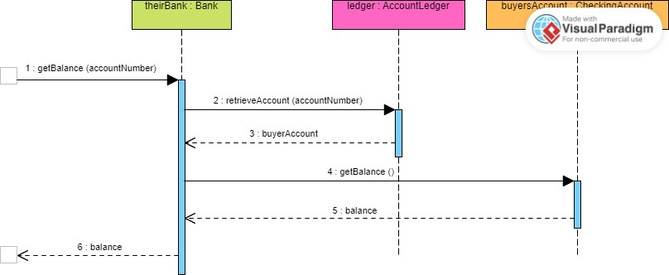

**ACTIVITY DIAGRAM :**

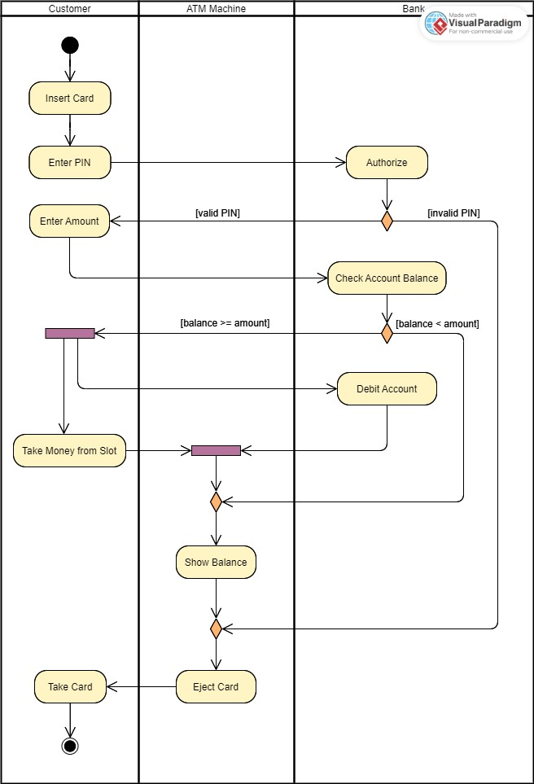

**Tools Used for draw UML Diagrams :**

To design your UML diagram, you may use platforms and editing tools online. These tools are helpful since they already have the needed symbols to illustrate your diagrams. You just have to plot the included symbols, arrows and labels. The platforms or online tools that you may use are:

• Lucidchart

• Creately

• Smartdraw

• Edrawmax

• Canva

­

**Conclusion:**

As a whole, the UML Diagrams works together to achieve the most desired functions of the Bank Management System Project. All of these were designed to guide programmers and beginners about the behavior and structure of Bank Management System.